**Experiment 12**

**Aim:** Deploying Pods and Services on minikube.

**Procedure:**

Creation and Deployment of pods can be done by **adhoc** commands or by writing **YAML** files for the same.

**Using commands:**

**1)** Starting the cluster.

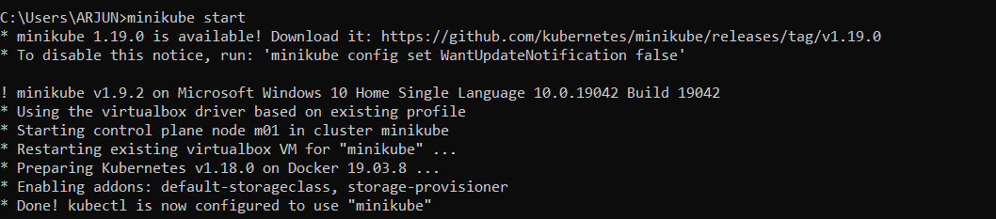

**2)** Creating a pod with httpd image.

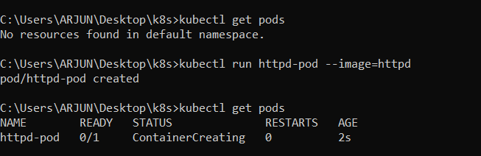

**3)** Expsoing the pod with the **NodePort** type, the following command will create a **SVC** for this pod and attach that SVC to the pod. We can check it by using the command **kubectl get svc** command.

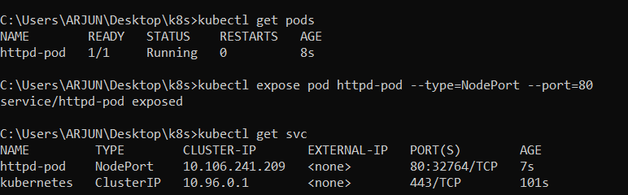

**Output:**

**4)** Checking the IP if the cluster, using the **curl** command to check the output.

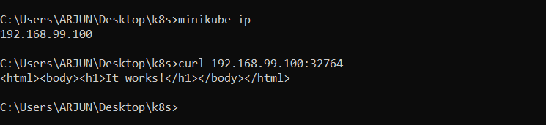

**5)** Checking the same on the browser.



**Using YAML file:**

**1)** Creating a yaml file for the configuration of a **pod**.

**Code:**

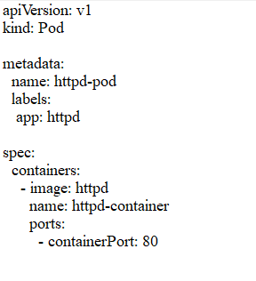

**2)** Creating a pod from the above file using **kubectl create –f** command.

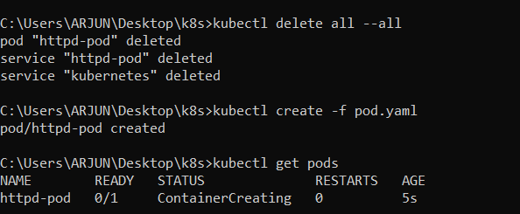

**3)** Creating a **SVC** file for the above pod with the type of **NodePort**.

**Code:**

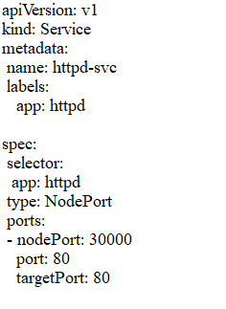

**4)** Creating the SVC using the **kubectl create –f** command.

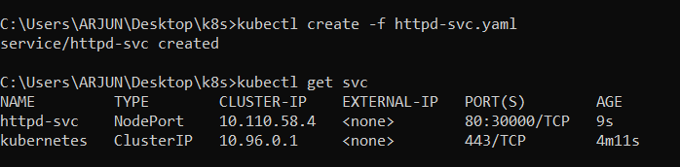

**5)** Checking the **output** on the CLI using the **curl** command.

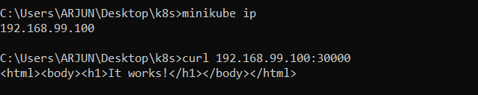

**Output** as seen on the browser:

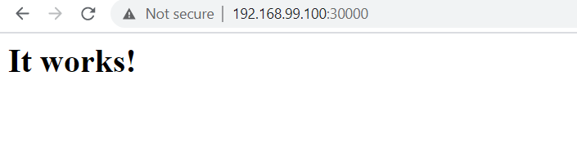

**Submitted by:**

Arjun Rekhi

500068109

R171218028